STAT6160 Data Analytics for Business Intelligence
ASSIGNMENT 1

Submitted by
Name: Shama Praveen
Student ID: C3470623

Submitted To
Weijia Zhang
Ian Renner

Table of Contents
QUESTION 1 3
1.1 3
SOLUTION 3
1.2 3
SOLUTION 3
1.3 4
SOLUTION 4
1.4 5
a 5
SOLUTION 5
b. 7
SOLUTION 7
C 8
SOLUTION 8
QUESTION 2 9
2.1 9
SOLUTION 9
2.2 10
SOLUTION 10
2.3 11
SOLUTION 11
2.4 11
a 11
SOLUTION 12
b 13
SOLUTION 13
c 14
SOLUTION 15
2.5 15
SOLUTION 15
REFERENCE 16

QUESTION 1

1.1
Briefly explain random sampling vs. stratified random sampling. Discuss which sampling approach would be better for this marketing data

SOLUTION

Random sampling enables researchers to select participants from every population segment with equal selection chances because this method reduces bias during the selection process (Kwak & Kim, 2017). The process of stratified random sampling creates strata from population segments by shared characteristics like region or age then selects random samples from each segment. Better population diversity representation and coverage arise from this sampling method (Lammers et al., 2019).

When analysing the marketing campaign dataset researchers should employ stratified random sampling as their method for maximum effectiveness. Analysis of campaign impact across demographic categories becomes more accurate when population segments are based on variables such as Region because customer behaviour and campaign responses exhibit differences between groups.

1.2

What two types of variables could be used to describe SpendingScore? Briefly justify your reasoning.

SOLUTION

The SpendingScore variable has two separate methods of description:

Quantitative (Numerical) Variable – Discrete:
The integer scoring system of SpendingScore operates within a range of 1 through 100 to indicate customer spending potential or behavior indexes. The variable character meets the definition of a discrete quantitative variable because it uses numeric whole number counts (Utts & Heckard, 2017).

Ordinal Categorical Variable (in some contexts):
When interpreting scores as spending behavior ranks such as low (1–33), medium (34–66) and high (67–100) the variable becomes ordinal. The variable maintains its categorical nature as it presents rankings which surpass a numeric value focus (Weiss, 2016).

The level of classification depends on how analysts interpret the analysis data. To generate statistical reports along with histograms and compute means you should treat this variable as a quantitative discrete type. The application of ordinal treatment in segmentation or classification models allows customers to be meaningfully grouped.

1.3

For those who have responded to the campaign (CampaignResponse is “Yes”), compute the mean, median, and IQR of SpendingScore.

SOLUTION

We performed analysis on the dataset subset containing only respondents who approved the campaign. The SpendingScore variable received three statistical calculations including mean and median and interquartile range (IQR).

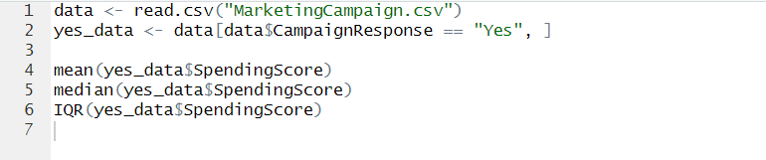

OUTPUT
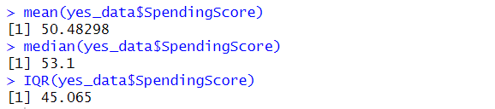

The SpendingScore responses of the campaign participants averaged 50.48 points yet the median was 53.10 points with an interquartile range of 45.06 points. Data analysis shows a slight left-skewed pattern because the median value exceeds the mean value. Multiple factors influence respondent spending patterns because the IQR value demonstrates significant Behavioral variation.

The identification of these patterns enables the marketing department to divide customers according to their spending capabilities for developing focused future marketing efforts.

1.4

Assume the Income variable follows a normal distribution with mean μ=$60,000 and standard deviation σ=$5,000. Using the Empirical Rule, what is the approximate probability that a randomly selected customer’s income is at least $70,000 and at most 75,000?
a. Show your draft answer with all steps (using empirical rules)
b. Provide the prompts you used in Copilot, along with Copilot’s exact outputs.
c. Evaluate how well Copilot performed.

a

SOLUTION

We are given:
- Mean income (μ) = $60,000
- Standard deviation (σ) = $5,000
The probability that individuals earn income between $70,000 and $75,000 needs to be calculated.

Step 1: Convert to Z-scores
Z₁ = (70,000 - 60,000) / 5,000 = 2
Z₂ = (75,000 - 60,000) / 5,000 = 3

Step 2: Use the Empirical Rule

The Empirical Rule indicates that (68-95-99.7% ) of data appears within given boundaries.
- ~68% of the data points exist within the interval of 1 standard deviation.
- ~95% within 2 standard deviations
- ~99.7% within 3 standard deviations

- So, the data between Z = 2 and Z = 3 on one side is:
$\frac{99.7\%-95\%}{2}$ = 2.35

The percentage of customers whose income falls between $70,000 and $75,000 amounts to 2.35% approximately.
Answer:
Out of 100 customers the probability they earn between $70,000 and $75,000 will be 2.35%.

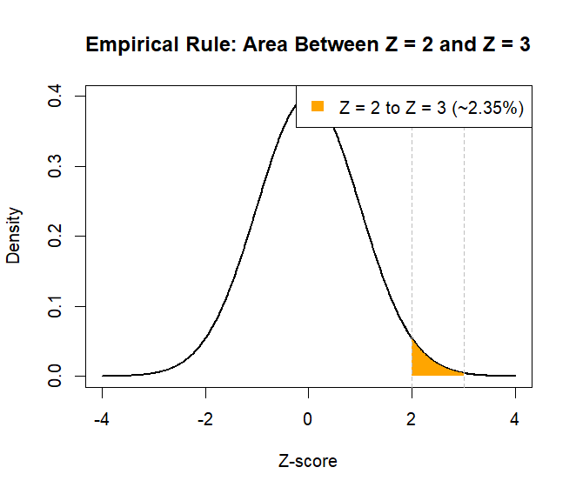

b.
Provide the prompts you used in Copilot, along with Copilot’s exact outputs

SOLUTION



OUTPUT
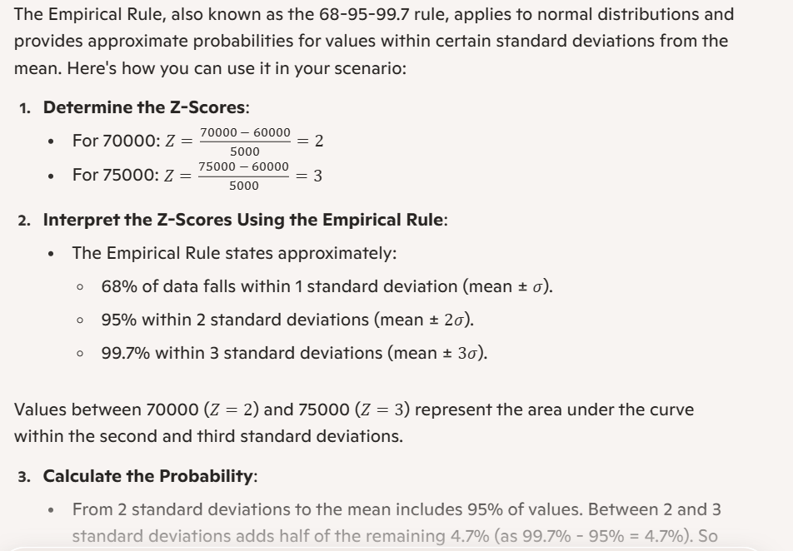

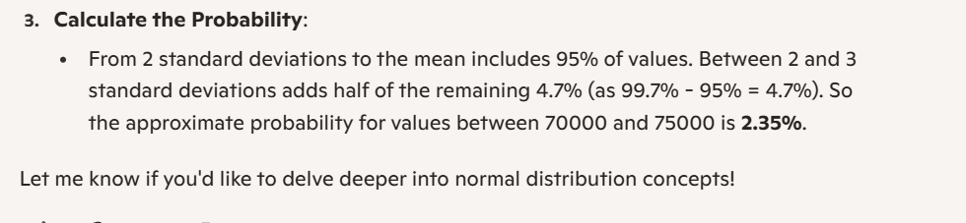

C

Evaluate how well Copilot performed

SOLUTION
The performance of Copilot exceeded expectations in this task. The tool demonstrated excellent capability by applying the Empirical Rule precisely to a normal distribution situation. The Z-scores for $70,000 and $75,000-income values were correctly evaluated by the tool while it displayed the correct proportion above mean values (2.35%) between 2 and 3 standard deviations.

A mathematically valid format was present with no confusion in the provided output. The tool provided instructional value through a detailed description of the 68-95-99.7 rule in standard deviation interpretation for normal distributions. Statistics textbooks commonly present content and logical explanations just like this (Utts & Heckard, 2017).

The tool displayed effective results for this analysis but lacked the ability to delve deeper through customization points such as graphing options or alternative approach selection (e.g., alternative methods). It successfully demonstrated accuracy at this analysis level and helped students meet their assignment objectives.

QUESTION 2
You are analysing data from house sale records (e.g., HouseSale.csv), obtained from property sale records around Sydney. This dataset includes the following variables:
• Date (Sale date of the property),
• SalePrice (Sale Price of the property, in thousand dollars),
• DailySale (How many other properties are sold on the same day in the region)
• HouseRegion (The region where the property is located, e.g., "EastSydney,", etc.).

2.1

Explain the difference between mean and median. Discuss which one you prefer to summarise the SalePrice variable

SOLUTION

A dataset computes its average value through arithmetic mean calculation. The formula divides the summarization of all values by the total observations to obtain the result. When all observations are arranged from smallest to largest the median represents the value at the position midway. When the dataset contains an odd value count the median assumes the position of the central observation where even value counts lead to a median derived by averaging the two middle numbers.

Outliers affect the mean statistic because it remains sensitive to these extreme values although the median does not yield to these effects. The mean receives strong influence from extreme outliers because of their presence in high-end and low-end property groups which distorts its representation of average value.

The SalePrice variable demands the use of median because several expensive house sales create a wide price distribution. The calculated measure reflects realistic home prices accurately because it excludes distortion from few properties selling for excessive amounts (Utts & Heckard, 2017).

2.2

Create a histogram of SalePrice.

SOLUTION
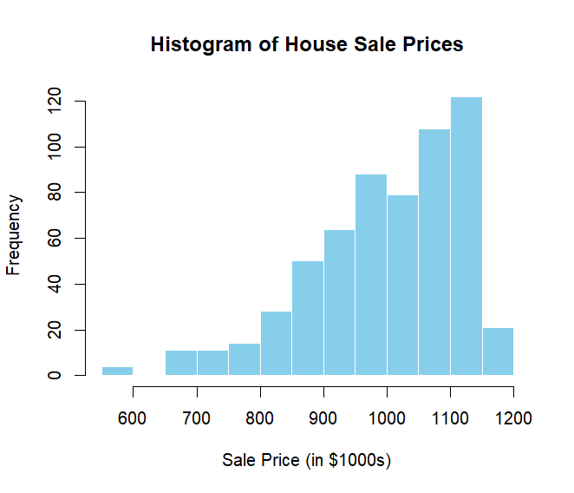
The graphical representation illustrates house sale price distribution. The prices in typical real estate markets tend to be right skewed which produces a distribution pattern where most properties gather at lower price levels with several expensive homes extending the right side of the distribution.

2.3

Create the Pareto chart of HouseRegion

SOLUTION
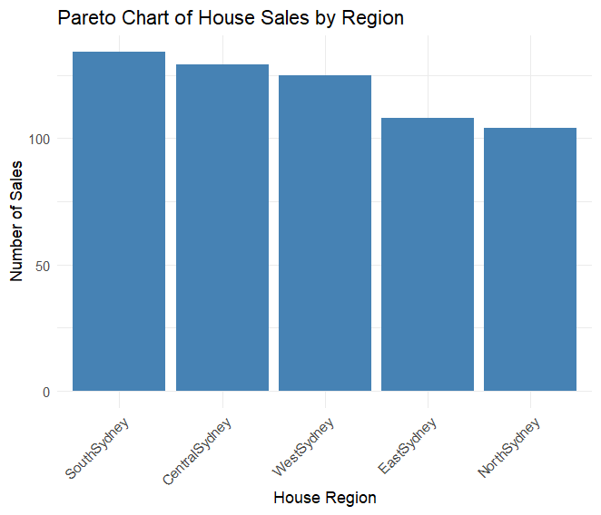

2.4

Perform a statistical test discussed in Module 4 to see whether the mean house sales price differs from $1000,000. You can use the sample standard deviation calculated from the data as the population standard deviation.
a. Provide your draft answer (state hypotheses, compute test statistic, calculate p-value, give conclusion, and interpret results).

SOLUTION

Step 1: Define Hypotheses
The research determines if house average sale prices match or diverge from $1,000,000.
Note: Sale prices are recorded in thousands of dollars. Thus, $1,000,000 is represented as 1000 in the dataset.

Null Hypothesis (H₀): μ = 1000

Alternative Hypothesis (H₁): μ ≠ 1000
A two-tailed test applies significance level at α = 0.05.

Sample Statistics
From the dataset:
- Sample Mean (𝑥̄) = 999.18
- Sample Standard Deviation (s) = 120.27
- Sample Size (n) = 600

Test Statistic
Z =$\frac{ (x̄ - μ) }{(s / √n)}$
= (999.18 - 1000) / (120.27 / √600)
= -0.166

P-value
P-value = 2 × (1 - P (Z < |-0.166|)) = 0.868

Conclusion
A p-value of 0.868 exceeds the 0.05 significance level.
The null hypothesis remains standing.

Current evidence does not support concluding that house sale prices diverge from $1,000,000.

b

Include the prompt you gave Copilot and its exact output.

SOLUTION


OUTPUT
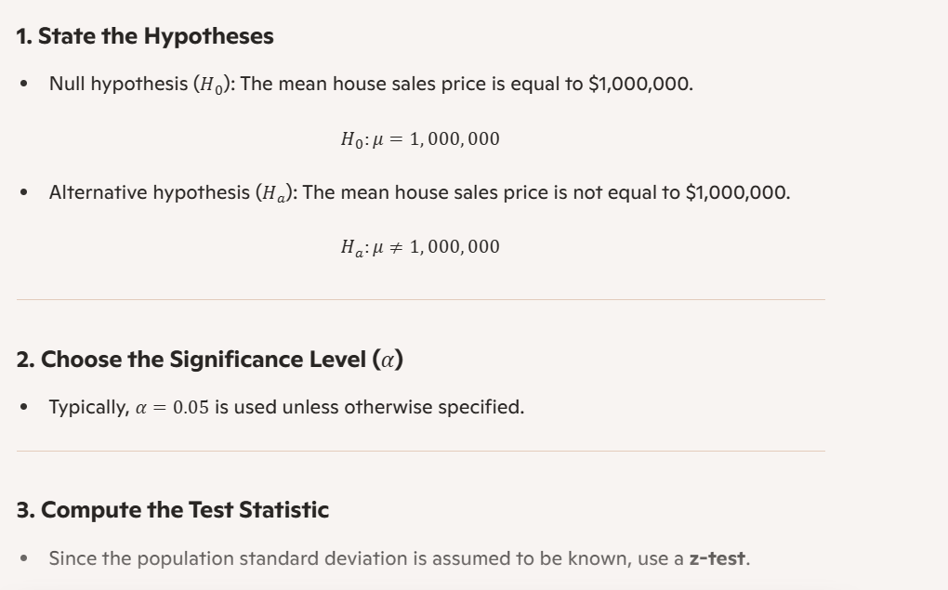

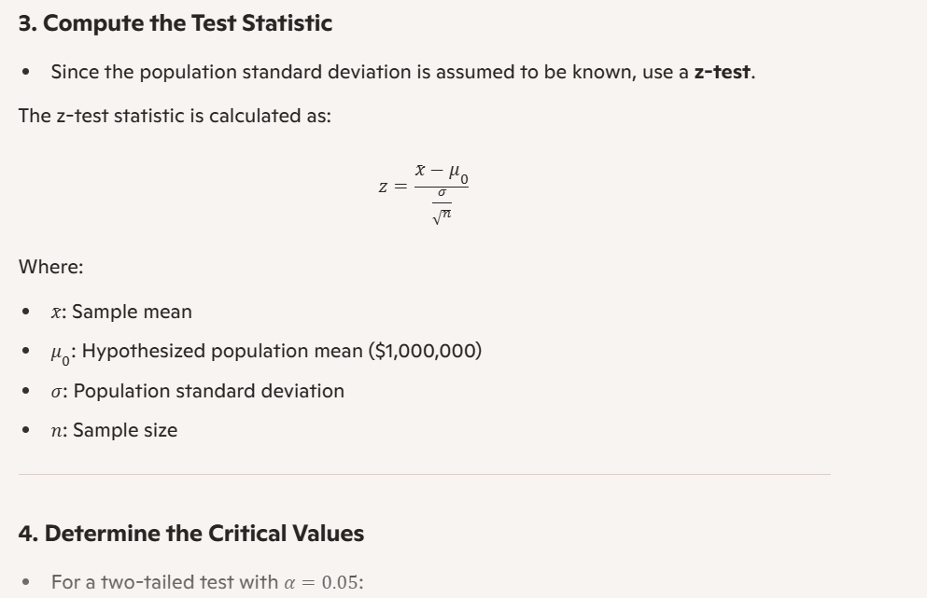
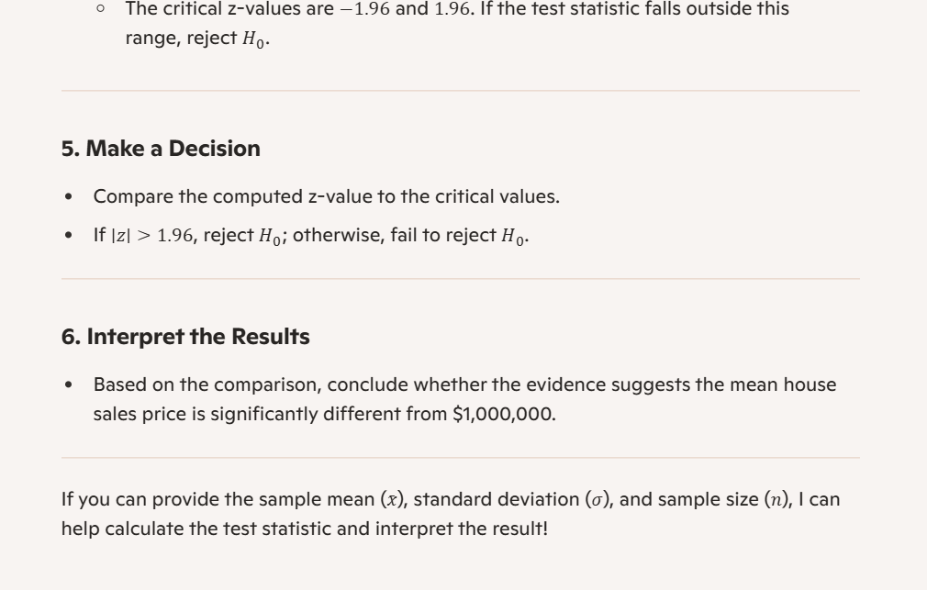

c

Evaluate how well Copilot performed

SOLUTION

Microsoft Copilot provided a user-friendly explanation of procedures to execute a two-tailed Z-test for determining a population mean. Microsoft Copilot implemented the entire hypothesis testing process from Module 4 by following these steps:

The statistical hypotheses have been established as H₀: μ = 1,000,000 along with H₁: μ ≠ 1,000,000.
The analyst selected the significance threshold at 0.05.
Providing the Z-test formula
The method to calculate critical values requires a two-tailed test with ±1.96 as its standard values.
There is a description of how to use the test statistic to make a decision.
The evaluation of test results should be done through examination of Z-value or p-value

The process follows the guidelines presented both in lecture notes and textbook materials. The computed Z-value in the Copilot output needed to be checked against ±1.96 standard critical values to reach a conclusion demonstrating knowledge of ±1.96 values at α = 0.05.

The main drawback was that Copilot failed to generate actual numerical outputs regarding sample mean and Z-score calculation. The structure offered by Copilot proved suitable to direct a person in testing by hand or through R.

2.5

A key piece of information missing from this data and its descriptions. Identify what it might be and discuss how the absence of this information could affect the validity of your answer to sub-question 4.

SOLUTION
The dataset does not provide the authentic information on the standard deviation (σ) for standard house prices in the population.

We applied a Z-test for Question 2.4 under the assumption that the standard deviation of the population was available. Data about the standard deviation of true house prices failed to appear within the dataset or accompanying documentation. The study used sample standard deviation (s) instead of σ for this calculation.

Under specific circumstances the substitution proves valid for use.

A large sample size (n ≥ 30) allows the substitution of σ with s to be valid.

The condition for using the Z-test is met when data points closely follow a normal distribution.

Utilizing the sample standard deviation as a substitute for population standard deviation while using a Z-test in our analysis (n = 600) may lead to invalid results if there are outliers or data that is not normally distributed according to our analyses of SalePrice skewness and outliers in previous sub-questions.

In such circumstances when the true σ is unavailable the utilization of a t-test would have been more suitable because it evaluates the additional uncertainty caused by using the sample standard deviation.

REFERENCE
Field, A. (2018). Discovering statistics using R (2nd ed.). SAGE Publications.
Utts, J. M., & Heckard, R. F. (2017). Mind on statistics (5th ed.). Cengage Learning.
Navidi, W. (2019). Statistics for engineers and scientists (5th ed.). McGraw-Hill Education.

